**GitHub Beginner Guide**

**Explanation for GitHub Account Creation, File Sharing, and Branching**

1. Setting up Git and Git hub :

1. Visit the GitHub website using your web browser.

2. Click on the "Sign up" button to create your account .

3. Fill the details like your username, email address, and password. Enter the required information and click sign up.

4. The next step would be to verify your e-mail account.

5. Open your gmail and verify your email from mail.

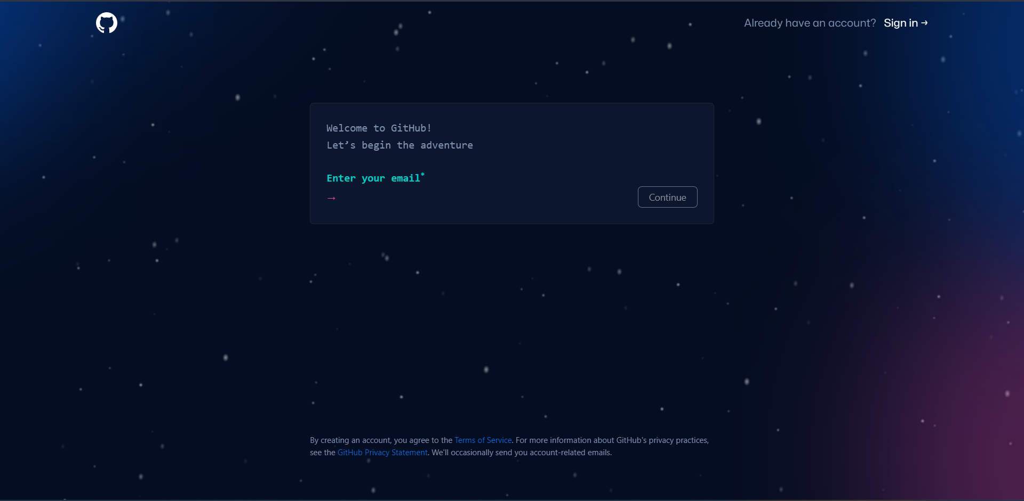

2. File Sharing:

1. Log in to your GitHub account.

2. Create a new repository by clicking the "New" button on then create a repository by filling the details like repository name etc.

3. You can create a repository in two forms which are public and private . In public mode anyone will be able to access your and vice versa for private.

4. Click on "Create repository" to create a new empty repository you can also add a readme file in the repository.

5. Your repository has been created now you can add files in it .

a. Drag and drop files from your computer directly into the repository page.

b. You can also use git bash for adding and modifying the files in repository by using commands.

c. You can also add file by manually creating file on github and editing it.

6. After adding files, you can share the repository wherever you want through providing the link and by sharing your username.

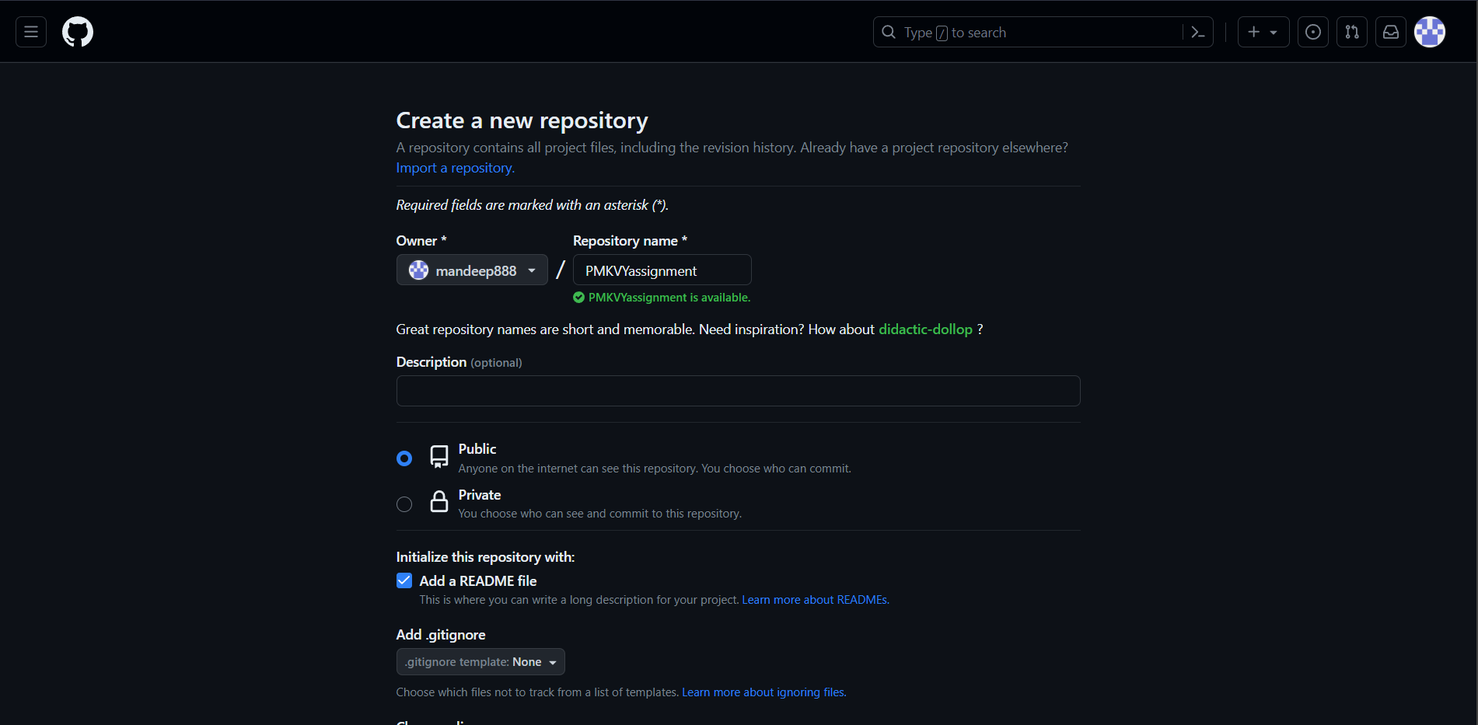

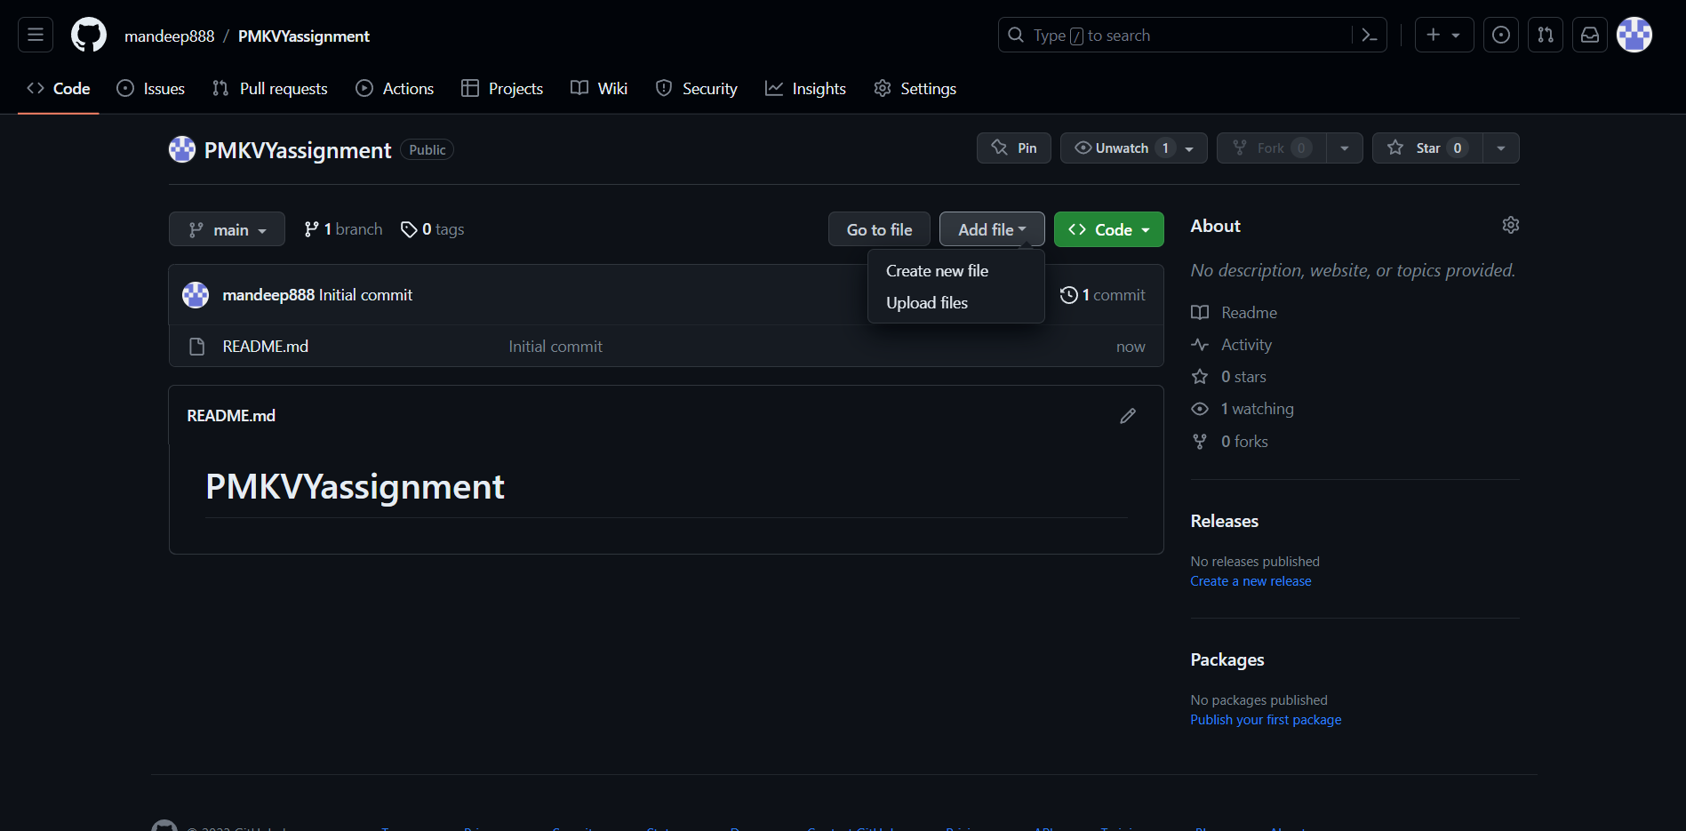

3. Branching:

Branching is a technique in git hub which help us create multiple branches (copies) of main files so that any changes made in the copies will not affect the main branch and can be merged afterwards.

1. Creating a new branch:

a. Go to your repository on GitHub.

b. Click on the branch dropdown (usually displays "main" by default).

c. There will be a dropdown list in which we can type the name of the alternate branch that we want to create.

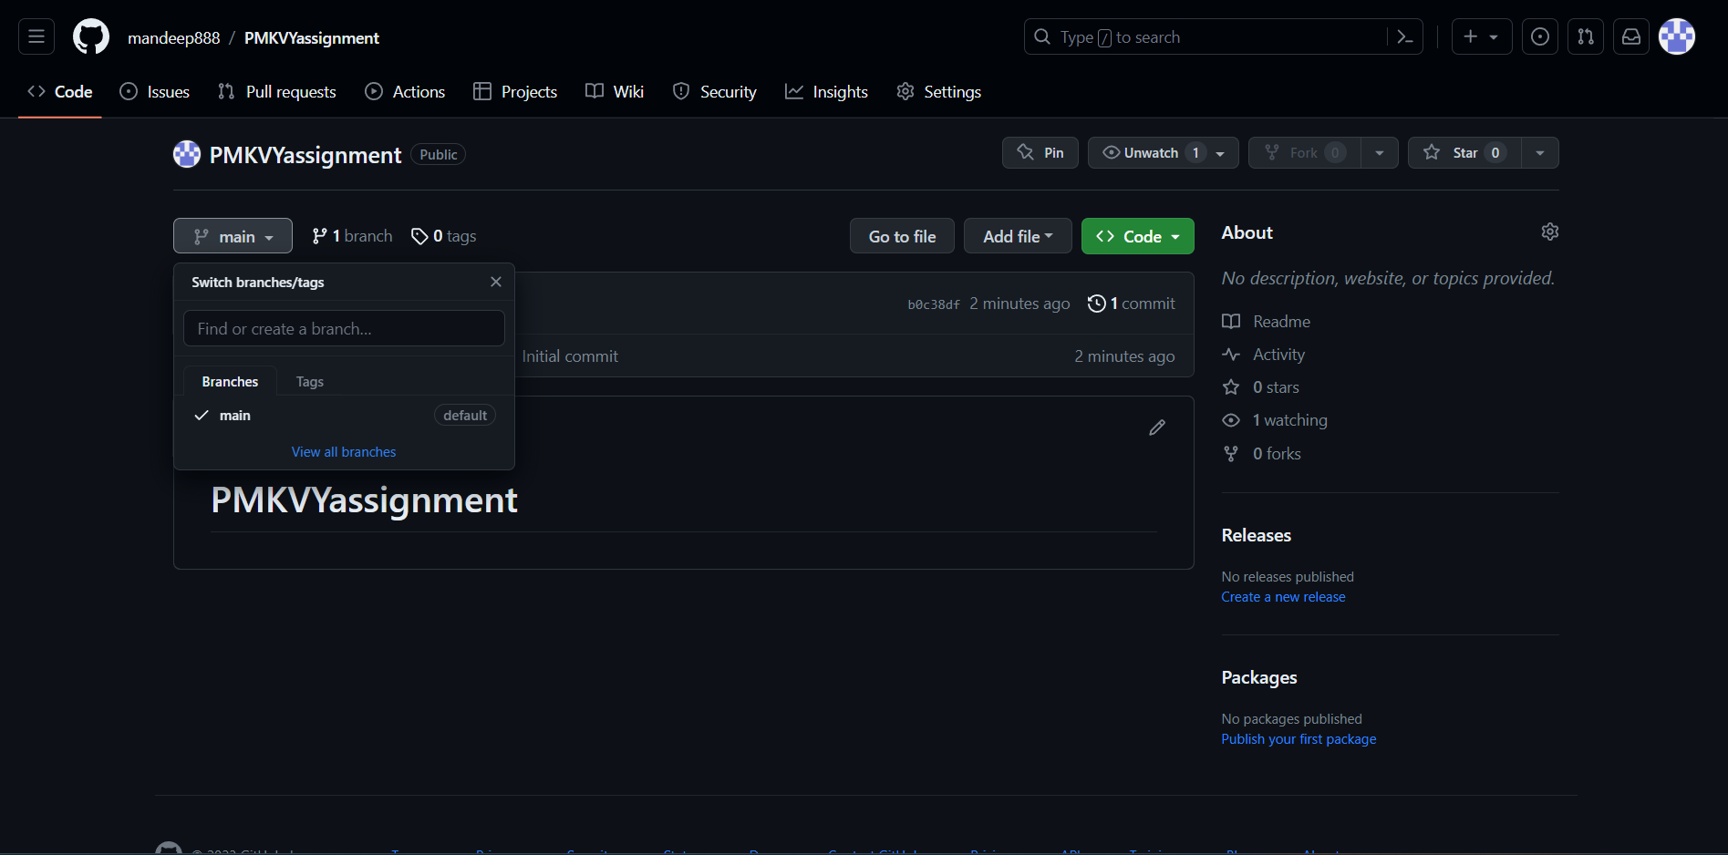

2. Switch to the new branch:

a. On the repository page, click on the branch dropdown.

b. Select the branch you just created (e.g., "feature-branch").

c. The repository page will now display the contents of the selected branch.

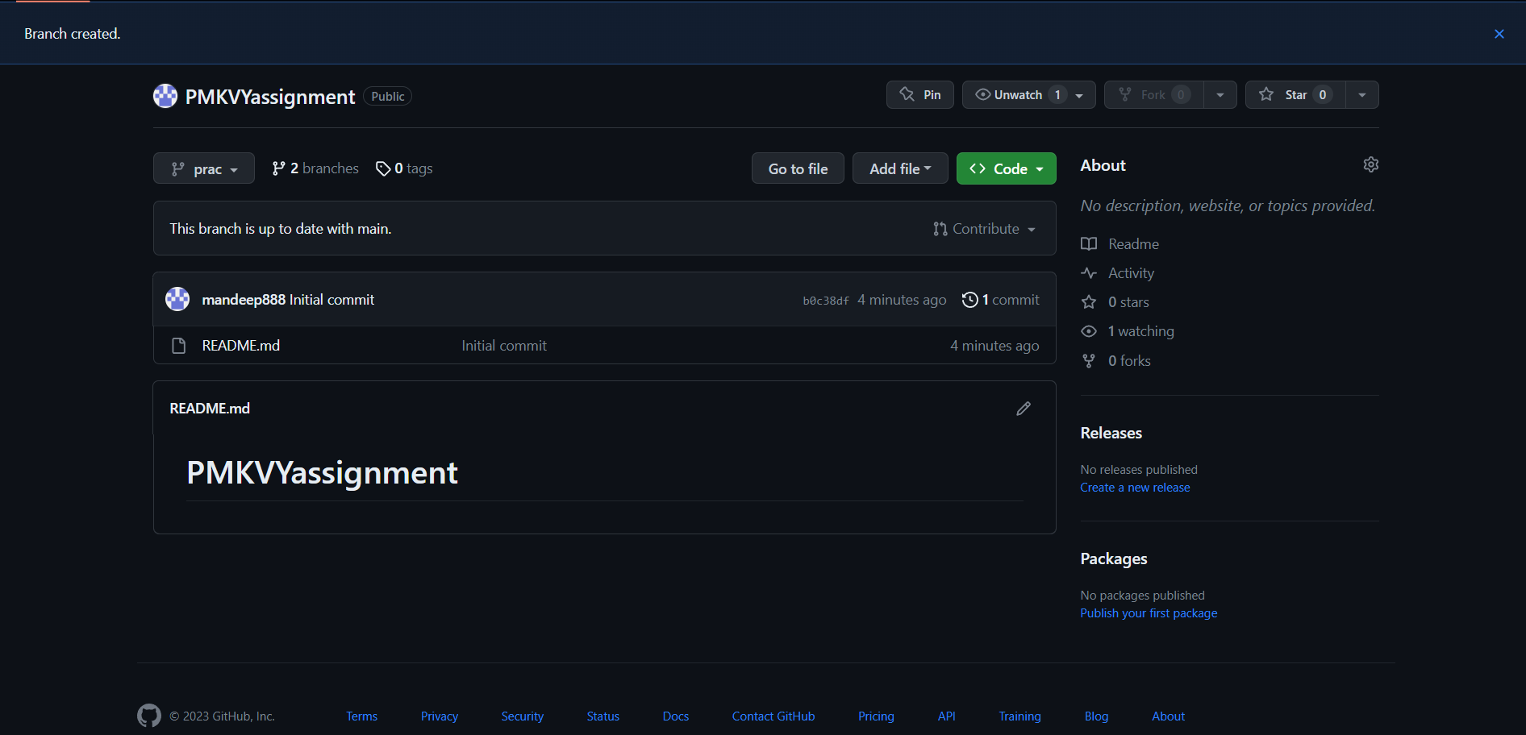

3. Make changes:

a. Navigate to the file you want to modify in the selected branch.

b. Click the "Edit" (pencil) icon to make changes directly in the browser or clone the repository, edit the file locally, and push changes to the selected branch.

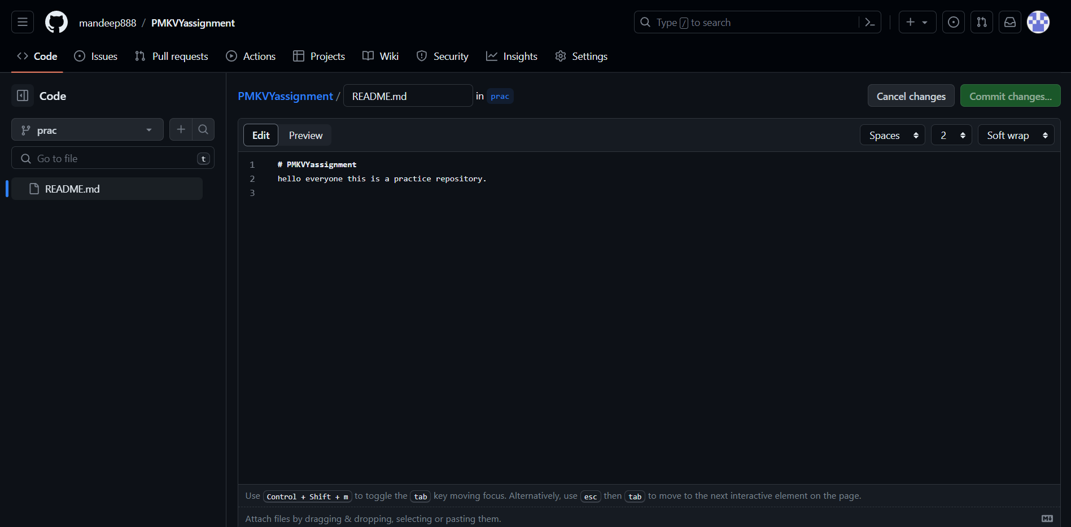

4. Commit changes:

a. After making changes, select the Commit changes section.

b. Provide a brief description of the changes made.

c. Click on the "Commit changes" button to save the changes to the branch.

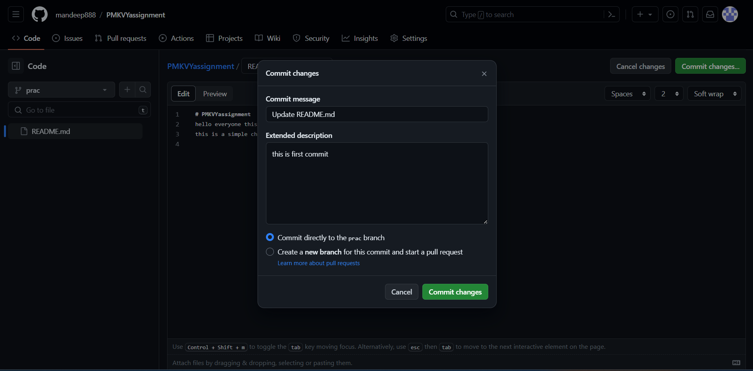

**Conclusion:**

GitHub is an excellent tool for version control, collaboration, and code management. Users may simply register a GitHub account, exchange files, and use branching to work successfully on software development projects by following the step-by-step instructions provided in this article. This enables engineers to collaborate effectively as a team, enabling smooth code integration and administration.